Capital Budgeting Techniques

Requirements:
Calculate the payback period, net present value (NPV), and internal rate of return (IRR) of different projects; make investment decision based on the calculations.
Use net present value profiles to select mutually exclusive projects.

1. Payback Period
- The payback method measures how many years and/or months for a project to recover its cost (also called the initial investment).
- The maximum acceptable payback period is determined by management.

Decision Rule
- For independent projects,
IF Project’s Payback Time < = Maximum Time, Accept the Project
IF Project’s Payback Time > Maximum Time, Reject the Project
- For mutually exclusive projects,
Among all of the acceptable projects, ONLY choose the one that has the shortest payback time

Calculation
Initial investment (in negative sign) + First year’s Cash Flow(CF)
= Cumulated Cash Flow (CF) in 1 year
- IF the accumulated CF >= 0, it means that the cost investment will be paid back in the first year, so payback time = 1 year;
- IF NOT, add the second year’s cash flow
Accumulated CF in 1 year + Second year’s CF = Acc. CF in 2 years
- IF accumulated CF >=0 , payback time = 2 years;
- IF NOT, add the next year’s CF
Acc. CF in 2 years + Third year’s CF = Acc. CF in 3 years
… …
Until the year when the accumulated CF turns from a negative number to zero or positive for the first time, will the project’s cost be fully paid back.

Example: A company is evaluating two projects: A and B, their cash flows are estimated and listed in the following table:
- If the company management requires no more than 4 years of payback time, which projects are acceptable?
- What is the investment decision if the max time is set as 3 years?
- How about the situation of a maximum time of 2 years?
- If they are mutually exclusive projects, which projects should be accepted, if the max time is 4 years?
time | Initial Invest | Year 1 | Year 2 | Year 3 | Year 4 | Year 5
Project A | -60,000 | 15,000 | 15,000 | 15,000 | 15,000 | 15,000
Project B | -60,000 | 30,000 | 10,000 | 28,000 | 20,000 | 10,000

Project A:
 | Initial Invest | Year 1 | Year 2 | Year 3 | Year 4 | Year 5
CF | -60,000 | 15,000 | 15,000 | 15,000 | 15,000 | 15,000
cumulated CF
So Project A has a payback time of _____ years.
Alternative Calculation for this example:
IF the project’s future cash flows are an ANNUITY, it can be calculated this way:
Payback Time = Initial investment / annual cash inflow
=

Project B?
 | Initial Invest | Year 1 | Year 2 | Year 3 | Year 4 | Year 5
CF | -60,000 | 30,000 | 10,000 | 28,000 | 20,000 | 10,000
Cumulated CF
So Project B has a payback time of _____ years.

Final answers to the questions:
- If the company’s maximum payback time is 4 years, both projects have less payback time than the max. They are BOTH acceptable.
- If the max time is 3 years, ONLY project B can be accepted.
- If the max time is 2 years, NO project will be selected.
- If the projects are mutually exclusive, ONLY project B should be taken, since it pays back the investment faster.

Pros and Cons of Payback Period Method
- Pros
It is simple and gives implicit consideration to the timing of cash flows and is widely used as a supplement to other methods such as Net Present Value and Internal Rate of Return.
- Cons
The max payback period is a subjectively determined number.
It fails to consider the cash inflows after the payback year and the time value of money.

2. Net Present Value (NPV)
Net Present Value (NPV) is found by subtracting the present value of all future cash flows from the initial investment (at year 0).
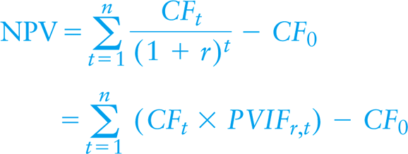
Decision Rule
- For independent projects,
IF NPV > 0, Accept the project
IF NPV = 0, Break even, you could accept it
IF NPV < 0, Reject it
- For mutually exclusive projects,
Choose the project with the HIGHEST positive NPV

Calculate NPV:
Example: Calculate the NPVs of project A and B , if the required return( or discount rate) is 5%. Which project can be accepted? If they are mutually exclusive projects, which project should be chosen?
time | Initial Invest | Year 1 | Year 2 | Year 3 | Year 4 | Year 5
Project A | -60,000 | 15,000 | 15,000 | 15,000 | 15,000 | 15,000
Project B | -60,000 | 30,000 | 10,000 | 28,000 | 20,000 | 10,000
Project A
NPV=

Project B
NPV=

Final Answer to the question:
According to the decision rules, projects with positive NPVs can be accepted. Project ____ is/are acceptable. But if they are mutually exclusive, Project ___ has higher NPV, therefore, should be taken.

3. Internal Rate of Return (IRR)
The Internal Rate of Return (IRR) is the discount rate that forces PV inflows = cost. This is the same as forcing NPV = 0. The IRR is the project’s intrinsic rate of return.
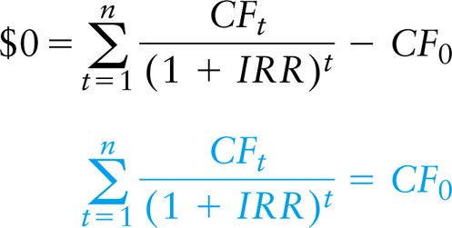
Decision Rule
- For independent projects,
IF IRR > required return (k), Accept the project
IF IRR = k Break even, could accept it
IF IRR < k Reject it
- For mutually exclusive projects,
Select the project with the HIGHEST IRR value

Calculate IRR using Trial and Error Method:
Example: If the company’s required rate of return (k) is 5%, which projects are acceptable? If both are accepted, what is their ranking? How will the investment decision be changed, when the required return now rises up to 9%?
IRRA

IRRB

Answer:
If k = 5 % , Project_____ can be accepted. Project ____ ranks first.
If k = 9 % , Project_____ can be accepted. Project ____ ranks first.

4. Net Present Value Profiles
NPV Profiles are graphs that depict each project’s NPVs at various discount rates (required rate of return) and provide an excellent means of making comparisons between projects.

For example: Given the two mutually exclusive projects of Bennett Company shown in table 9.1, their NPVs are at different discount rates and IRRs are calculated and listed in table 9.4. The NPV profiles are shown in graph 9.4.
Using the profile, if Bennett Company’s current required return is 9%, which project should they choose?
Suppose the company currently experiences financial stress, the required return increases to 15%. Which project should the company take?
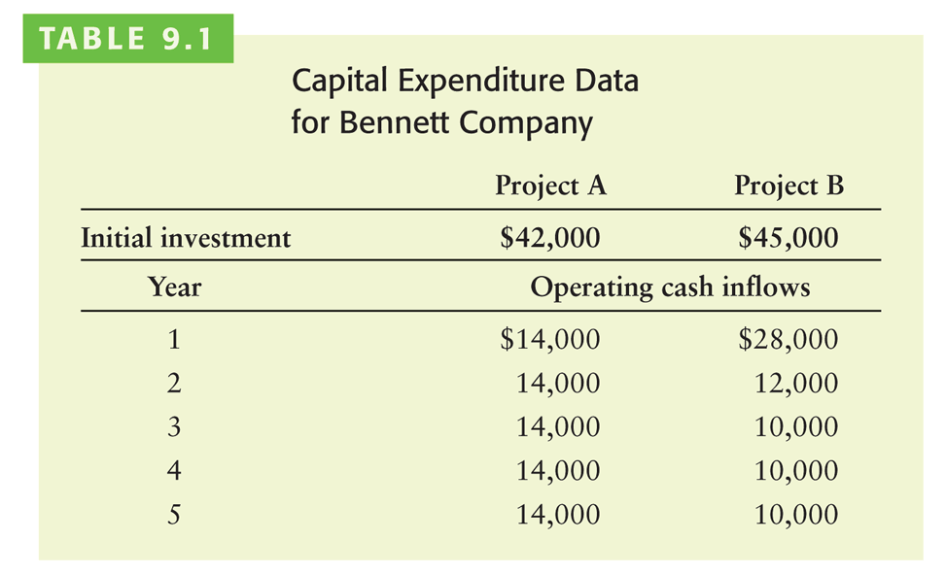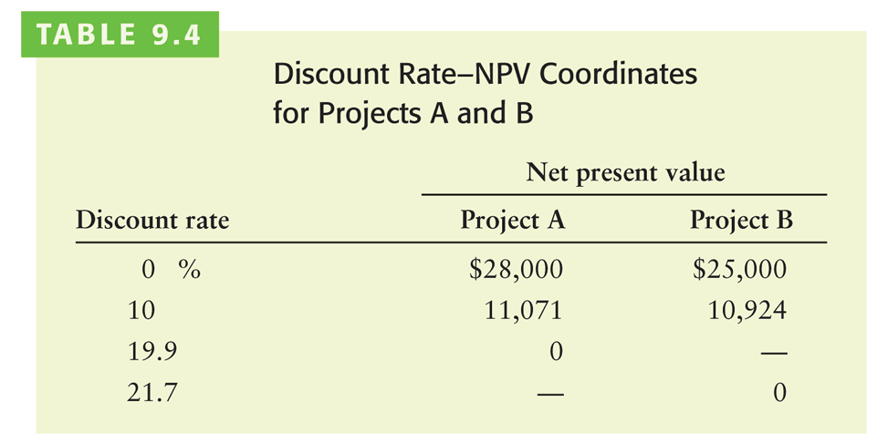
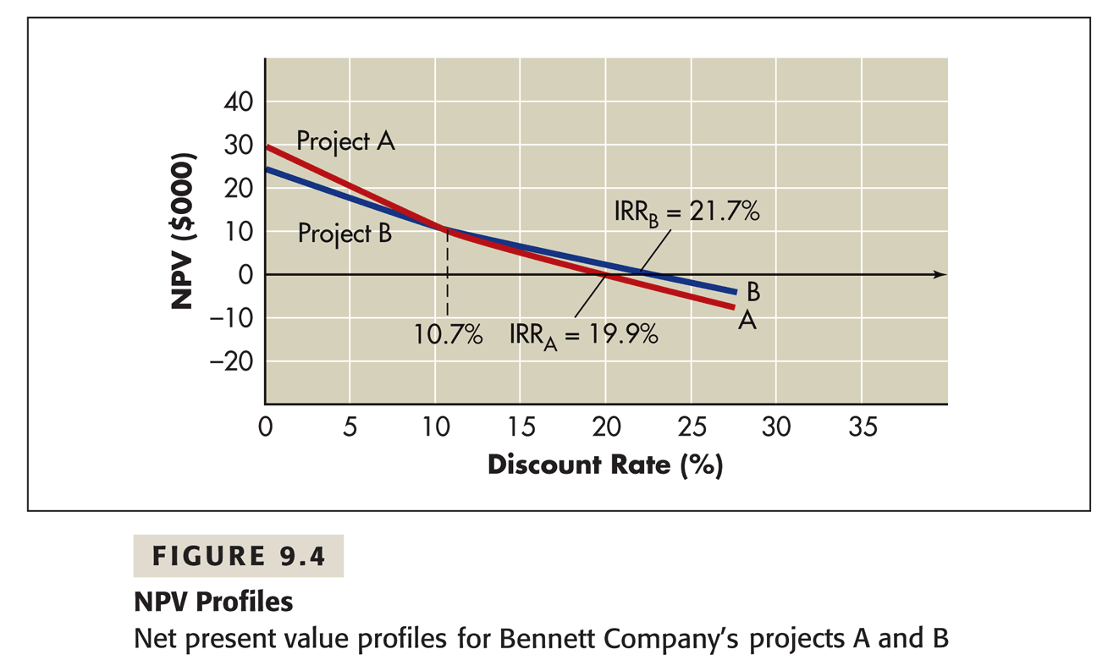
IF NPV criteria is used
Compare the required return of the company with the crossover rate of the two project profiles. In this example, the crossover rate that makes the two projects’ NPVs equivalent is 10.7%. Choose the project with the NPV line above all the other projects’ lines.
- When k = 9% < 10.7%, A’s NPV line is above Bs, choose Project A;
- When k = 15% > 10.7%, B line is above A, so choose Project B,

IF IRR criteria is used: 21.7% < 19.9% → IRRA < IRRB, choose Project B

Here, NPV and IRR have conflicting rankings between the two projects, when the discount rate is less or equal to 10.7%.

Solution of the conflicting rankings: follow the decision made by NPV, because:
- NPV assumes that intermediate cash flows are reinvested at the required return whereas IRR assumes they are reinvested at the rate of IRR,
- Certain mathematical properties may cause a project with non-conventional cash flows to have zero or more than one value of IRR.

5.Compare Different Methods
Criteria | Acceptance Rules |  | Importance
Criteria | Mutually exclusive projects | Independent projects | Importance
NPV | Highest NPV | NPV >= 0 | Main criteria
IRR | Highest IRR | IRR >= k | Second
Payback | Lowest PB | PB <= max time | Third

Their Problems
Criteria | Problems
NPV | Require estimates on cash flows and discount rate
IRR | Not applicable to non-conventional cash flow projects
Payback | Arbitrary preset cutoff, exclude time value

6. Profitability Index (PI)
PI = (PV of Future Payoffs) / |Initial Investment|
If using NPV information, PI = 1+ NPV/ |Initial Investment|
PIA=
PIB=

Decision Rule:
For single project: PI >1
To rank all accepted projects: the higher the PI value the better.

Different ranking results by using NPV and PI_ size effect!

